**Graded Assignment on Docker**

**1)Pull any image from the docker hub, creates its container, and execute it showing the output.**

**Docker:** Docker is an open-source platform that enables developers to build, deploy, run, update and manage containerized applications.

**Docker Image:**

* A Docker image is a file used to execute the container in the docker.
* It is also used to store snapshots.
* It has represented as the sedd that has files to be executed.

**Container:** A Docker container is a packaged collection of all the apps libraries and dependencies already or files and folders which are in group of pack which are ready to be executed.

**Docker hub:** Docker hub provided by docker allows developers to store and share container images.

First execute the **docker version** command.

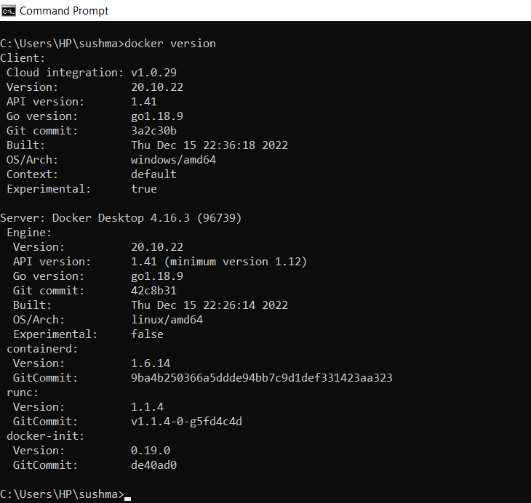

Using **docker pull image-name** command we can pull the image from the docker hub.

Here we are downloading the image nginx from the docker hub.

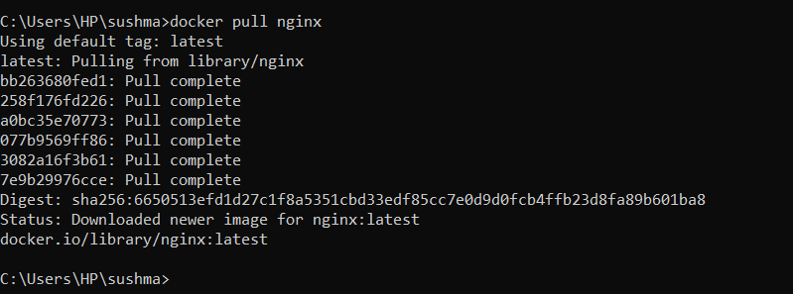

Now, we are creating an container from the downloaded image nginx and expose it on port 80 using the following command executing…

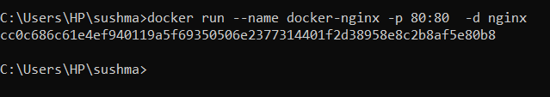

We can verify the nginx container using **docker ps** command



Next, connect to the running container using the following command

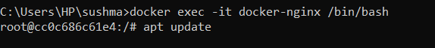

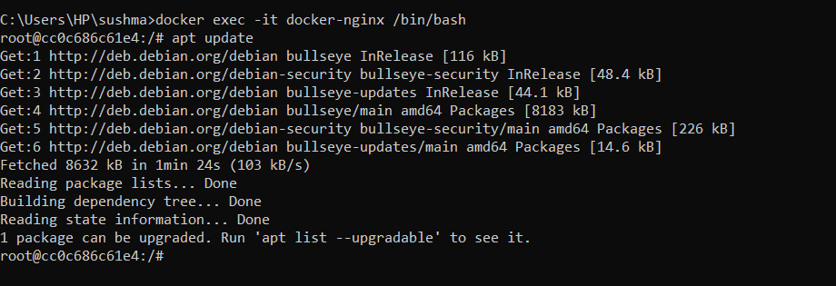

And we connected to the container.

Open docker desktop, to check whether container is created or not.

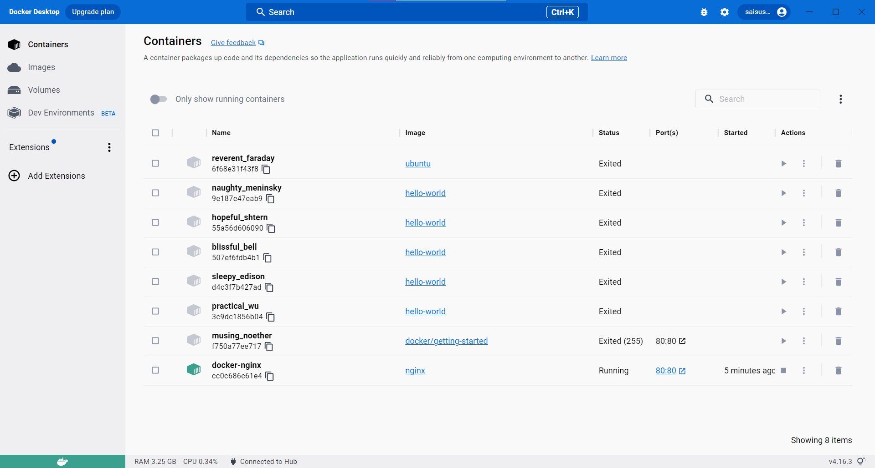

**2)Create the basic java application, generate its image with necessary files, and execute it with docker.**

Creating the basic java application.

1.Create a directory for the files to be stored and move to that directory.

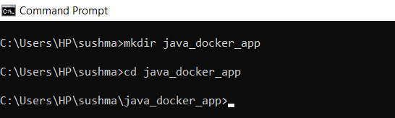



2.Create a java file and save it as Hello.java

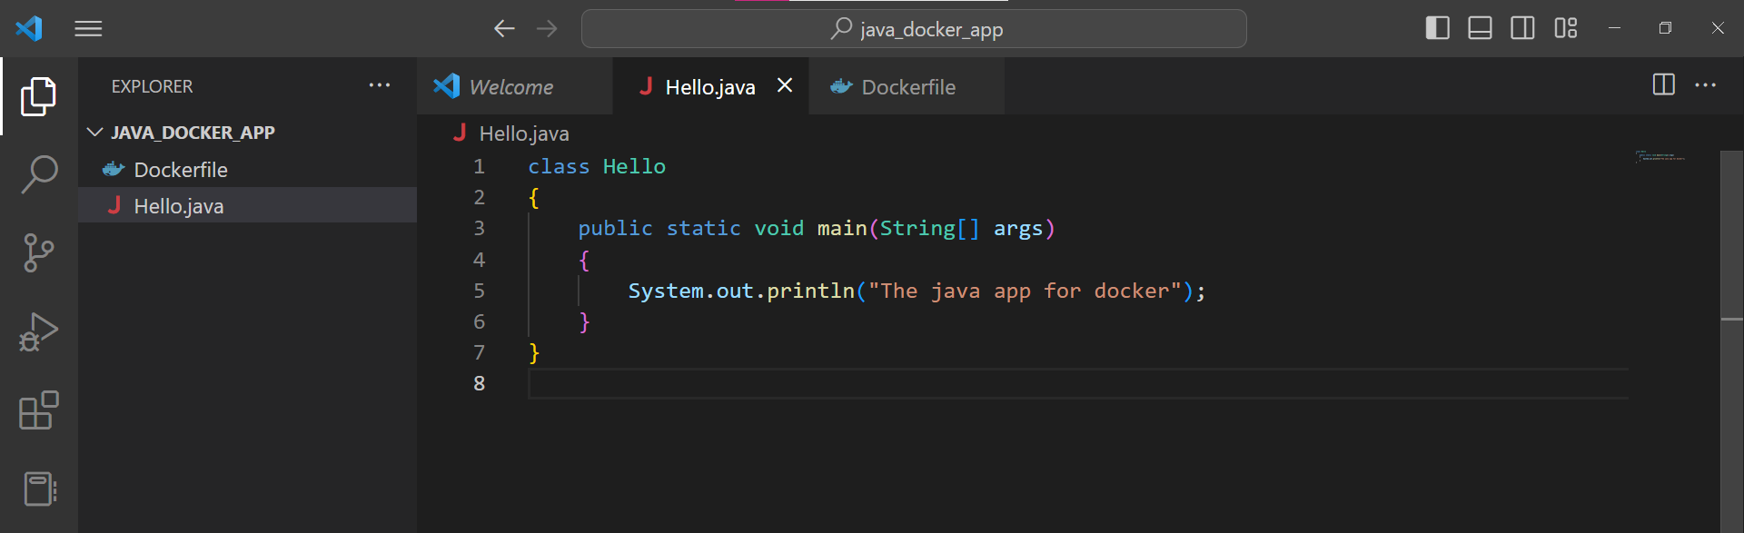

3.Create a Dockerfile

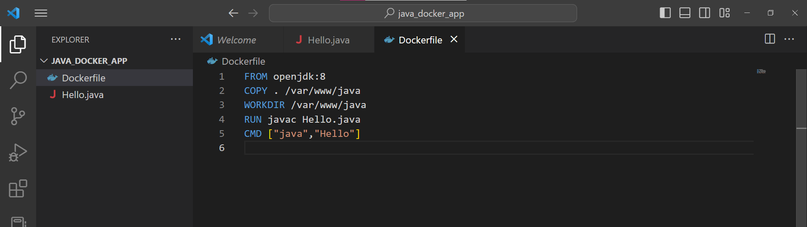

4.Let’s create an image named **java-app** using the following command

**Docker build -t java-app**

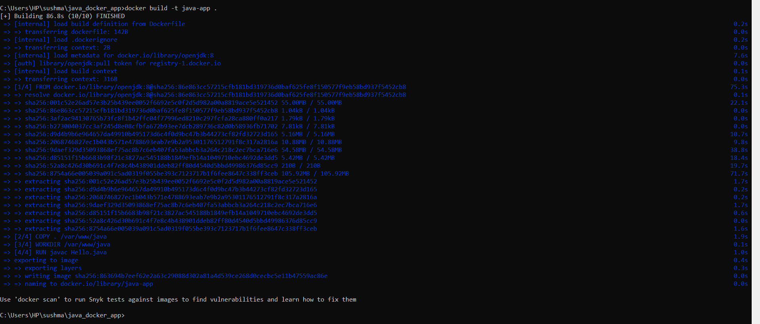

5.After building the image, we run docker



6.Open **Docker Desktop**, and you can see the java application is running.

